Pokhara University

Level: Bachelor | Semester – Spring | Year : 2006
Programme: BE |  | Full Marks: 100
Course: Principle of Programming Language |  | Time : 3hrs.

Candidates are required to give their answers in their own words as far as practicable.
The figures in the margin indicate full marks.

Attempt all the questions.

 | - “The complexity of programming led to the development of program design notations”. If this is true explain with reference of Pseudocode.  - List the main points that motivate to study Principle of Programming language.  - What are the programming domains? How logical programming is differing with functional programming? | 5  5  5
 | - In the 1960 someone remarked “I don’t know what we will be programming in, in the year 2000, but I know what it will be called.” Do you think this is an accurate prediction? Express your view.  - What is common block? Explain the structural organization of FORTAN with the help of temperature conversion program. | 8  7
 | - How does data represent in FORTAN? Differentiate role of array and scalar data types of FORTAN data structure.  - Translate the following expression into LISP.  i) 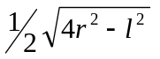 ii) 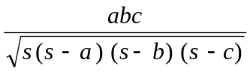 iii) 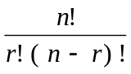 iv) 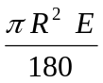 | 7  4×2
 | - Differentiate BNF with EBNF with the help of syntactic structure of ALGOL – 60.  - What is LISP? Define the structural organization of LISP program with example. | 8  7
 | - How does CAR and CDR help in searching the data elements? Explain with the help of walking down diagram.  - “ALGOL was a major milestone in programming languages”. Why?  - Explain how ALGOL-60 comes in the final form. | 5  5  5
 | - How do classes allow multiple representations of data types in the SMALLTALK? Explain with help of orthogonal classification.  - How does an object associate with a class? Define the method of class representation in SMALLTALK. | 8  7
 | Write short notes on (Any Two):  - Computed go to  - Lambda expressions  - Dangling references  - Contours diagram | 5×2

